Add User in FortiGate
- Login to FortiGate.
- Go to User & Authentication > User Definition.
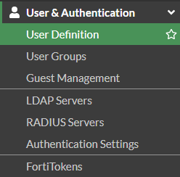
- Select Create New
- User Type: Local then hit next.
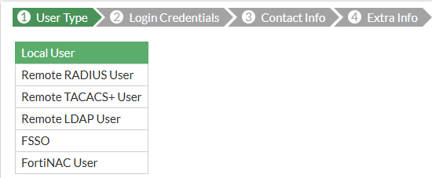
- Enter Username and Password then hit next.
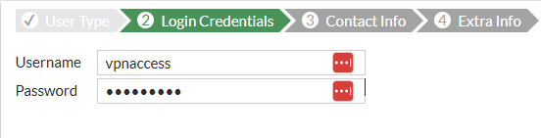
- Optional: Enable Two Factor Authentication.
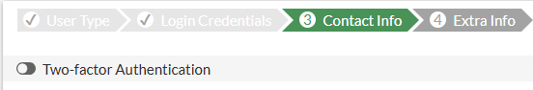
- Enable User Group and select the appropriate group.
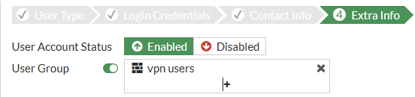
- Select Submit.

How to Setup FortiClient
- Login to FortiGate.
- Go to VPN > SSL-VPN Settings.
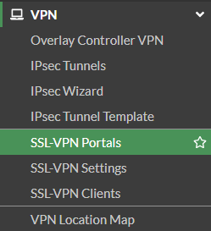
- Copy the IP Address and Port.
- Open or Download Forticlient.
- Select Configure VPN.
- VPN: SSL-VPN.
- Connection Name: [Name of the VPN].
- Description: Leave blank.
- Remote Gateway: Paste the IP Address from FortiGate.
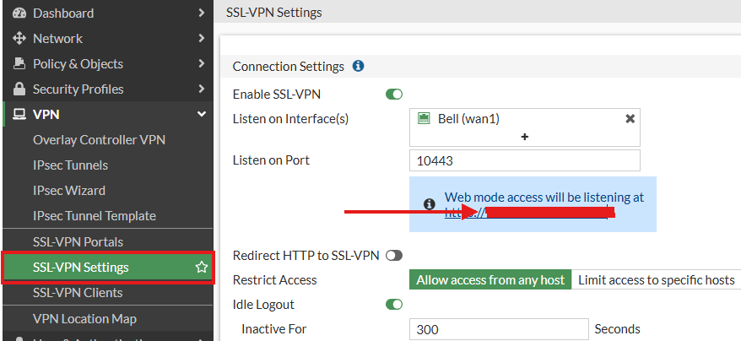
- Customize Port: Copy Listen on Port.
- Single Sign On: Unchecked.
- Client Certificate: None.
- Enable Dual Stack IPv4/IPv6 Address: Unchecked.
- Select Save.
